CURRICULUM VITAE – Afaf M. Hamada

Personal Details:
Name | : Afaf Mohamed Hamada Abdel-Rahman | 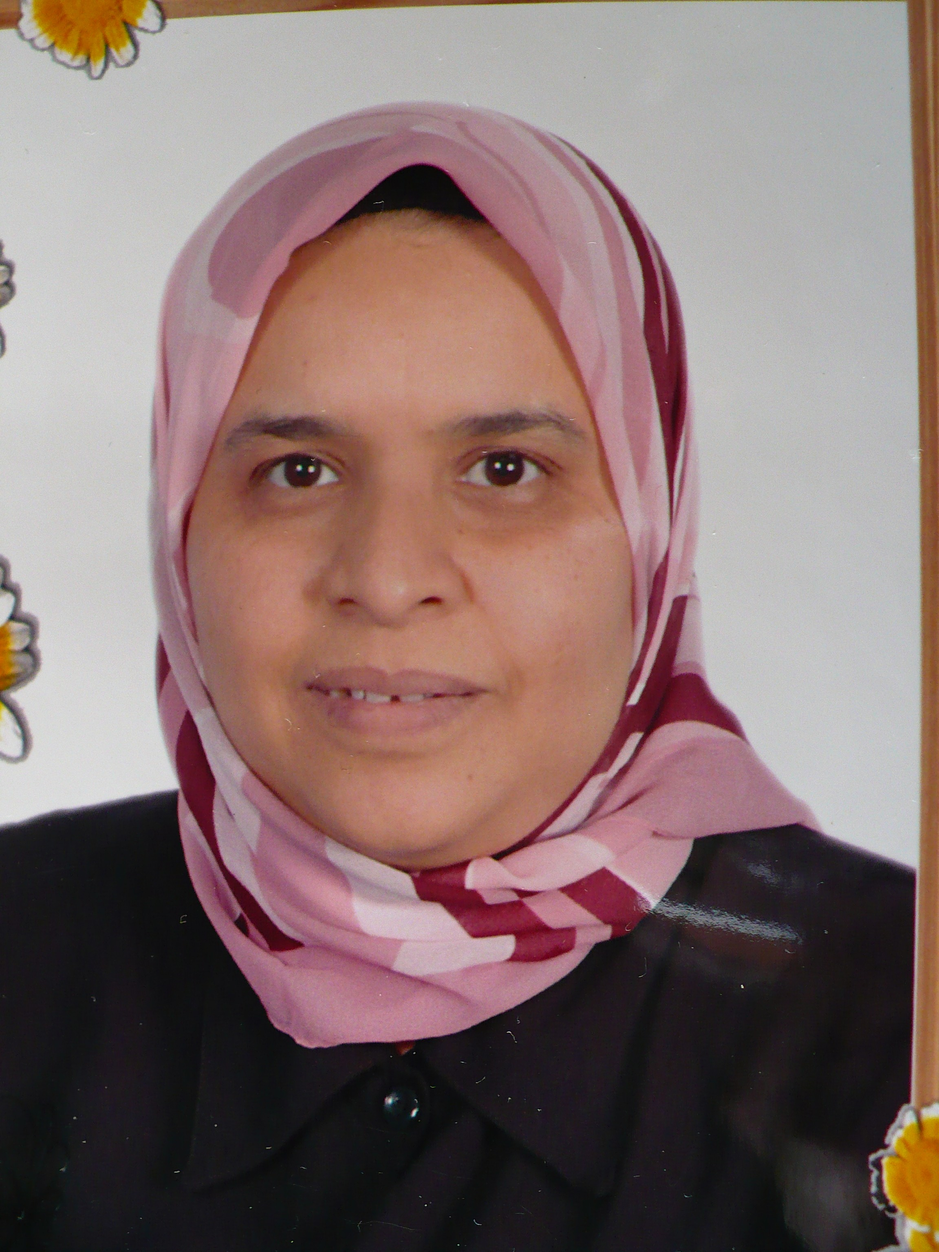
Gender | : Female
Date and place of birth | : April 14th 1960, Esna, Qena, Egypt
Nationality | : Egyptian
Social status | : Single
Present address | : Botany Department, Faculty of Science, Assiut University, Assiut, Egypt
Telephone number  Fax  E-mail | : 002-02-4181862, Home, Cairo  : 002-088-2412266, Office, Assiut  : 002-01006544540, Mob.  : 002-088-2080209  : afaf.ali@science.au.edu.eg  : afafhamada@yahoo.com

Academic Degrees
B.Sc. 1982 Botany, Faculty of Science, Assiut University, Egypt.
M.Sc.1987 in Plant Physiology, Botany Depart, Facu. of Sci., Assiut Univ., Egypt.
Thesis: Effect of herbicidal auxins on physiological activities of some economic plants
Ph.D. 1990 in Plant Physiology, Botany Depart, Facu. of Sci., Assiut Univ., Egypt.
Thesis: Physiological responses to salt stress in some bean lines and pea cultivars.

Present employment:
From October 2001 Professor. Department of Botany, Faculty of Science, Assiut University

Employment record (other than outlined above):
1982-1987 | Demonstrator, Botany Dept., Faculty of Science, Assiut University
1987-1991 | Assistant Lecturer, Botany Dept., Faculty of Science, Assiut University
1991-1996 | Lecturer, Botany Dept., Faculty of Science, Assiut University
1996-2001 | Assistant Professor, Botany Dept., Faculty of Science, Assiut University

Supervision of post-graduate students:

Sayed A. Desoky, Ph.D. obtained 1995
Abeer A.F. Radi, M.Sc. obtained 1996
Hanaa Al-M Monzaly, M.Sc. obtained 1998
Manal H. A. El-Zohri, M.Sc. obtained 2006
Rasha M.S.H. El-Shazoly, M.Sc. obtained 2008
Fatma A. Farghly, Ph.D. obtained 2008
Dalia A. Abdel-Wahab, M.Sc. obtained 2010
Manal H. A. El-Zohri, Ph.D obtained 2011
Rasha M.S.H. El-Shazoly, Ph.D obtained 2013
Dalia A. Abdel-Wahab, Ph.D obtained 2014
Heba Elsalahy, Ph.D

Teaching experience:
Teaching under and postgraduate courses in Plant Physiology, Biochemistry, Mineral nutrition, Plant hormones, Stress Physiology.

Research Interests
Physiology of biotic and abiotic stress

Fellowship awarded:
1995 | [2 months grant from German Academic Exchange Service (DAAD)] Institute of Chemistry and Plant Physiology, Tübingen Univ., Germany
2000 | [2 months grant from German Academic Exchange Service (DAAD)] Faculty of Biology, Bielefeld University, Germany
2003-2004 | [10 months grant from Swedish Institute (SI)]  Department of Natural Sciences, Södertörn University College, Sweden
2006 | [6 weeks grant from Linnaeus-Palme program for teaching in Department of Natural Sciences, Södertörn University College, Sweden
2007 | [2 months grant from German Academic Exchange Service (DAAD)]  Institute of Plant Nutrition, Giessen University, Germany
2011-2012 | [18 months grant from Royal Swedish Academy of Agriculture  and Forestry]  Department of Ecology, Environment and Plant Sciences, Stockholm University, Sweden
2013-2015 | [28 months grant from Lantmännens Research Foundation]  Department of Ecology, Environment and Plant Sciences, Stockholm University, Sweden

Conferences abroad

XI International Conference of Photosynthesis, Budapest, Hungary August 1998
Xth International Colloquium for the Optimization of Plant Nutrition, Cairo, Egypt April 2000.
Plant Nutrient Transport through Biological Membranes, Giessen Germany Septemper 2000
XII International Conference of Photosynthesis, Brisbane, Australia August 2001

Plant Induced Resistance for Pest and Disease Control (PIRAC), PlantComMistra programme, Cape Town, South Africa October 2008.

31st Nordic Cereal Congress, Gothenburg, Sweden May 2012

6th International Conference on Silicon in Agriculture, Stockholm, Sweden, August 2014

Membership
Egyptian Botanical Society
International Society of Photosynthesis
The International Society for Silicon in Agriculture and Related Disciplines (ISSAG)

List of Publications Professor Afaf M. Hamada

Peer-reviewed articles:

1 – Radi, A.F.; Shaddad, M.A.; Zidan, M.A. and Hamada, A.M. (1989): Effect of two herbicidal auxins on the cation interaction in some economic plants. Beitr. trop. Landwirtsch. Vet. med. 27: 65-72.

2 - Shaddad, M.A.; Radi, A.F.; Zidan, M.A. and Hamada, A.M. (1990): Effect of 2,4-D and 2,4,5-T on some metabolic activities in some economic plants. Bull. Fac. Sci., Assiut Univ. 19: 37-44.

3 - Shaddad, M.A.; Radi, A.F.; Zidan, M.A. and Hamada, A.M. (1990): Effect of various concentrations of 2,4-D and 2,4,5-T on seed germination, dry matter yield and transpiration rate of some economic plants. Journal of Islamic Academy of Science 3: 124-130.

4 - Hamada, A.M. and El-Enany, A.E. (1994): Effect of NaCl salinity on growth, pigment and mineral element contents, and gas exchange of broad bean and pea plants. Biol. Plant. 36: 75-81.

5 - El-Enany, A.E. and Hamada, A.M. (1994): Physiological studies of some heavy metals on Helianthus annuus, Vigna sinensis and Triticum vulgare. 1. Growth criteria, pigmentation, photosynthesis and respiration. Acta Agr. 43: 235-241.

6 - El-Zawahry, A.M. and Hamada, A.M. (1994): The effect of soaking seeds in ascorbic acid, pyridoxine or thiamine solutions on nematode (Meloidogyne javanica) infection and on some metabolic processes in egg plant. Assiut J. Agr. Sci. 25: 233-248.

7 - Faheed, F.A.; Ahmed, Z.A. and Hamada, A.M. (1994): Some physiological responses to salinity in selected cultivars of wheat. Sohag Pure & Appl. Sci. Egypt 10: 75-89.

8 - Hamada, A.M. (1994): Alleviation of the adverse effects of NaCl on germination of maize grains by calcium. Biol. Plant. 36: 623-627.

9 - Ahmed-Hamad, A.M.; Hamada, A.M. and Desouky, S.A. (1995): Effect of exogenously added vitamins on photosynthesis and some related activities of salinized Chlorella vulgaris. P. Mathis (ed.), Photosynthesis: from light to Biosphere, Vol. IV. 749-752: In proceeding: The Xth International Photosynthesis Congress. Montpellier, France, 20-25 August.

10- Hamada, A.M. and Khulaef, E.M. (1995): Effects of salinity and heat-shock on wheat seedling growth and content of carbohydrates, proteins and amino acids. Biol. Plant. 37: 399-404.

11- Hamada, A.M. (1996): Effect of NaCl, water stress or both on gas exchange and growth of wheat. Biol. Plant. 38: 405-412.

12- Hamada, A.M. (1998): Effects of exogenously added ascorbic acid, thiamin or aspirin on photosynthesis and some related activities of drought-stressed wheat plants. In Proceeding: The XIth International Photosynthesis Congress. Budapest, Hungary, 17-22 August.

13- El-Aref, H.M. and Hamada, A.M. (1998): Genotypic differences and alterations of protein patterns of tomato explants under copper stress. Biol. Plant. 41: 555-564.

14- Hamada, A.M. and Khulaef, E.M. (2000): Stimulative effects of ascorbic acid, thiamin or pyridoxine on Vicia faba growth and some related metabolic activities. Pakistan J. Biol. Sci. 3: 1330-1332.

15- Hamada, A.M. (2000): Amelioration of drought stress by ascorbic acid, thiamin or aspirin. Ind. J. Plant Physiol. 5: 358-364.

16- Al-Hakimi, A.M.A. and Hamada, A.M. (2001): Counteraction of salinity stress on wheat plants by grain soaking in ascorbic acid, thiamin or sodium salicylate. Biol. Plant. 44: 253-261.

17- Hamada, A.M. (2001): Alteration in growth and some relevant metabolic processes of broad bean plants during extreme temperatures exposure. Acta Physiol. Plant. 23: 193-200.

18- Hamada, A.M. (2001): The biochemical adaptive strategies for drought-salt resistance of wheat plants. Plant, Soil and Environment 47: 247-252.

19- Hamada, A.M. (2001): Vitamin or salicylic acid treatments versus the adverse effects of copper stress on photosynthesis and some related activities of wheat seedlings. In Proceeding: XIIth International Photosynthesis Congress. Brisbane, Australia, 18-23 August.

20- Ahmed-Hamad, A.M. and Hamada, A.M. (2001): Grain soaking presowing in ascorbic acid or thiamin versus the adverse effect of combined salinity and drought on wheat seedlings. In Proceeding: XIIth International Photosynthesis Congress. Brisbane, Australia, 18-23 August.

21- Hamada, A.M.; El-Zawahry, A.M. and Al-Hakimi, A.M.A. (2001): Vitamin treatments for control of Meloidogyne javanica on egg plants. Russ. Phytopathol. Soc. 2: 67-74.

22- Abd-Alla, M.H.; El-Enany, A.E.; Hamada, A.M. and Abdel-Wahab, A.M. (2001): Element distribution in faba bean root nodules under salinity and its effects on growth, nodulation and nitrogen fixation. Plant, Soil and Environment 47: 399-404.

23- Hamada, A.M. and Al-Hakimi, A.M.A. (2001): Salicylic acid versus salinity-drought-induced stress on wheat seedlings. Plant, Soil and Environment 47: 444-450.

24- Taghian, A.S.; El-Aref, H.M. and Hamada, A.M. (2001): Genotypic changes in protein synthesis in tomato during low and high temperatures and the alleviation of chilling and heat injury by calcium. Assiut J. Agr. Sci. 32: 249-266.

25- Hashem, M. and Hamada, A.M. (2002): Induction of resistance to root rot disease of wheat grown under field condition. Plant, Soil and Environment 48: 312-317.

26- Hashem, M. and Hamada, A.M. (2002): Evaluation of two biological active compounds for control of wheat root rot and its causal pathogens. Mycobiology 30: 233-239.

27- Hamada, A.M. and Hashem, M. (2003): Thiamin and salicylic acid as biological alternatives for controlling wheat root-rot disease. Egypt. J. Agric. Res., NRC 1: 369-385.

28- Rasha El-Shazoly; Ashraf Metwally and Afaf Hamada (2007): Differential responses of five wheat (Triticum aesativum L.) varieties to boron toxicity. In Proceeding: The First Annual Conference for Young Scientists. Faculty of Science-Assiut University, Assiut, Egypt, 5-6 May.

29- Fatma Farghly; Abeer Radi and Afaf Hamada (2007): Evaluating salt tolerance of wheat and bean varities using growth and sodium translocation parameters. In Proceeding: The First Annual Conference for Young Scientists. Faculty of Science-Assiut University, Assiut, Egypt, 5-6 May.

30- Radi, A.F.; Zidan, M.A.; Hamada, A.M.; Frank, H. and El-Zohary, M.H.A. (2007): The role-played by glutathione and phytochelatins in cadmium tolerance Vicia faba plants. In Proceeding: The First Annual Conference for Young Scientists. Faculty of Science-Assiut University, Assiut, Egypt, 5-6 May.

31- Dalia Mohamed; Abeer Radi and Afaf Hamada (2008): Evaluation of bean lines tolerance to saline- sodic soil using growth and some relative metabolic parameters. In Proceeding: The Second Annual Conference for Young Scientists. Faculty of Science-Assiut University, Assiut, Egypt, 18-19 Oct.

32- Hamada, A.M. and Jonsson, L. (2008): Thiamine as a possible bio-control agent to bird-cherry-oat aphid for use instead of chemical insecticides. In: Proceeding of Plant Induced Resistance for Pest and Disease Control (PIRAC) workshop in Cape Town, South Africa, October 26-29th.

33- Radi, A.F.; Zidan, M.A.; Hamada, A.M.; Frank, H. And El-Zohri, M.H. (2009): Growth parameters and some metabolic activities of Vicia faba as affected by cadmium toxicity. In Proceeding: The First International Conference of Biological Sciences, Assiut, Egypt, 4-5th March.

34- Hamada, A.M. and Al-Hakimi, A.M. (2009): Exogenous ascorbic acid or thiamine increases resistance of sunflower and maize plants to salt stress. Acta Agronomica Hungarica 57: 335-347.

35- Hamada, A.M. and Al-Hakimi, A.M. (2009): Hydroponic treatment with ascorbic acid decreases the effects of salinity injury in two soybean cultivars. Phyton 49: 43-62.

36- Ashraf Metwally; Rasha El-Shazoly and Afaf Hamada (2010): Comparison of the sensitivity of several wheat (Triticum aestivum L.) cultivars to boron toxicity. Fourth Saudi Science Conference, Al-Madinah Al-Munawwarah, Saudi Arabia, 21-24th March.

37- Al-Hakimi, A.M.A. and Hamada, A.M. (2011): Ascorbic acid, thiamine or salicylic acid induced changes in some physiological parameters in wheat grown under copper stress. Plant Protect. Sci. 47: 92-108.

38- Afaf Hamada; Ashraf Metwally and Rasha El-Shazoly (2012): Amelioration of extreme temperature stress in alfalfa seedlings by vitamin C and vitamin B₆. Acta Agron. Hung. 60: 57-70.

39- Abeer A. Radi, Fatma A. Farghly and Afaf M. Hamada (2012): Assessment of tolerance to NaCl salinity of fourteen wheat and broad bean cultivars. Phyton 52: 145-162.

40- Ashraf Metwally, Rasha El-Shazoly and Afaf M. Hamada (2012): Effect of boron on growth criteria of some wheat cultivars. J. Biol. Earth Sci. 2: B1-B9.

41- Abeer A. Radi, Dalia A. Abdel-Wahab, Afaf M. Hamada (2012): Evaluation of some bean lines tolerance to alkaline soil. J. Biol. Earth Sci. 2: B18-B27.

42- Abeer Ahmad Radi, Fatma Ali Farghly, Afaf Mohamed Hamada (2013): Physiological and biochemical responses of salt-tolerant and salt-sensitive wheat and bean cultivars to salinity. J. Biol. Earth Sci. 3: B72-B88.

43- Afaf M. Hamada and Lisbeth M.V. Jonsson (2013): Thiamine treatments alleviate aphid infestations in barley and pea. Phytochemistry 94: 135–141.

44- Farghaly F.A., Radi A.A., Abdel-Wahab D.A. and Hamada A.M. (2014): Comparative study of alkaline and saline stresses on two oil producing plants. Egyptian Journal of Experimental Biology (Botany) 10(1): 13 – 25.

45- Abeer A. Radi, Ashraf M.A. Metwally, Rasha M. El-Shazoly and Afaf M. Hamada (2014): Some metabolic responses of boron-stressed canola plants to external application of calcium, silicon and salicylic acid at vegetative growth stage. Egyptian Journal of Experimental Biology (Botany) 10(2): 143-154.

46- Radi A.A., Farghaly F.A., Abdel-Wahab D.A. and Hamada A.M. (2014): Physiological and metabolic responses of two oil-producing plants to salt and alkali stresses. Assiut University Journal of Botany 43(1): 29-55.

47- Radi A.A., Farghaly F.A., and Hamada A.M. (2015): Antioxidant and yield indicator responses of wheat and bean cultivars to salinity. Assiut University Journal of Botany, 44(1): 15-39.

48- Farghaly F.A., Radi A.A., Abdel-Wahab D.A. and Hamada A.M. (2016): Effect of salinity and sodicity stresses on physiological response and productivity in Helianthus annuus. Acta Biologica Hungarica 67(2): 184–194.

Peer-unreviewed articles:

49- Afaf M. Hamada, Jamshid Fatehi, Lisbeth M.V. Jonsson (20XX): The effect of seed treatments with the biocontrol agent Pseudomonas chlororaphis MA342 and thiamine on generalist and specialist aphids.

50- Ashraf M. Metwally, Rasha M. El-Shazoly and Afaf M. Hamada (20XX): Physiological responses to excess boron in wheat cultivars.

51- Rasha M. El-Shazoly, Ashraf M. Metwally and Afaf M. Hamada (20XX): Salicylic acid or thiamine increases tolerance to boron toxicity stress in wheat shoots.

Review:

El-Shazoly, M.S. and Hamada, A.M. (2008): Wheat aphids in Egypt, there current status and options for management. In: Proceeding of Plant Induced Resistance for Pest and Disease Control (PIRAC) workshop in Cape Town, South Africa, October 26-29th.

Chapters in Books:

Hamada, A.M. (2005): Ion transport under salinity or water stress. In “Vegetables: Growing Environment and Mineral Nutrition”, pp. 178-196 WFL Publisher, Meri-Rastilan tie 3 C, 00980 Helsinki, Finland.

